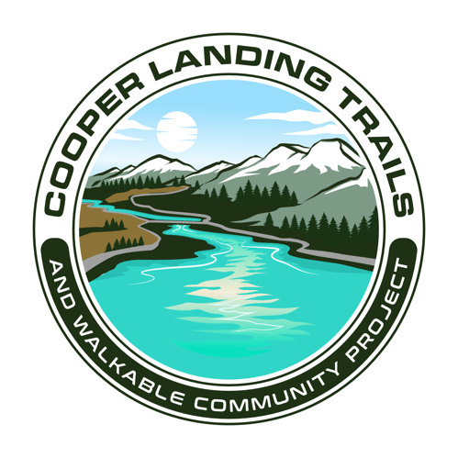
Cooper Landing Trails Committee Meeting
TENTATIVE AGENDA
7:00 PM August 24, 2023
Cooper Landing Community Hall

- CALL TO ORDER
- ROLL CALL
- REVIEW OF MINUTES from 12/5/2018
- TREASURERS REPORT
  - Revenue Sharing
- CORRESPONDENCE – if any
- OLD BUSINESS
  - Update on projects
    - Logo
    - AK Transportation Alternatives Program (TAP) Grant
    - Safe Streets for All
    - KMTA Grant for Groomer
- NEW BUSINESS
    - Trail Maintenance on Safety Path
    - Devil’s Site Prep
    - AK Recreational Trails Program (RTP) Grant
    - Volunteers Needed
      - Trail Maintenance
      - Snow Grooming and Equipment Maintenance
      - Treasurer
- INFORMATION and ANNOUNCEMENTS - if any

- COMMITTEE MEMBER COMMENTS – if any

- SELECT NEW MEETING DATE

- ADJOURNMENT

